WireShark:

**Wireshark** is a [free](https://en.wikipedia.org/wiki/Free_software) and [open source](https://en.wikipedia.org/wiki/Open_source) [packet analyzer](https://en.wikipedia.org/wiki/Packet_analyzer). It is used for [network](https://en.wikipedia.org/wiki/Computer_network) troubleshooting, analysis, software and [communications protocol](https://en.wikipedia.org/wiki/Communications_protocol) development, and education. Wireshark lets the user put [network interface controllers](https://en.wikipedia.org/wiki/Network_interface_controller) that support [promiscuous mode](https://en.wikipedia.org/wiki/Promiscuous_mode) into that mode, so they can see all traffic visible on that interface, not just traffic addressed to one of the interface's configured addresses and broadcast/multicast traffic.

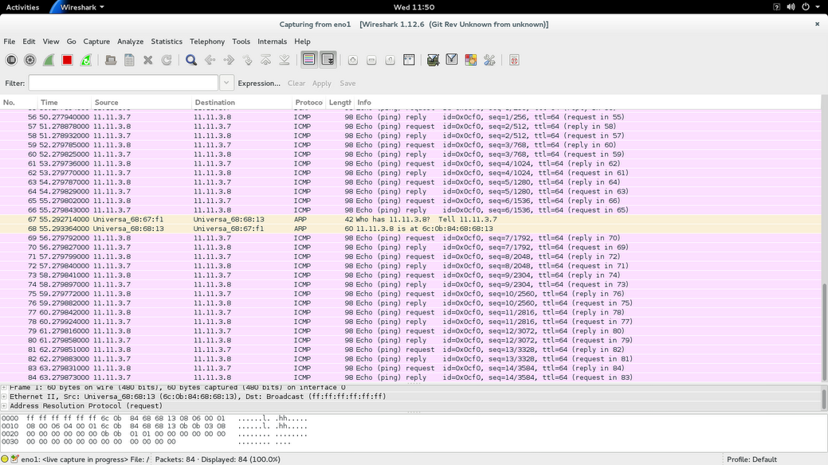

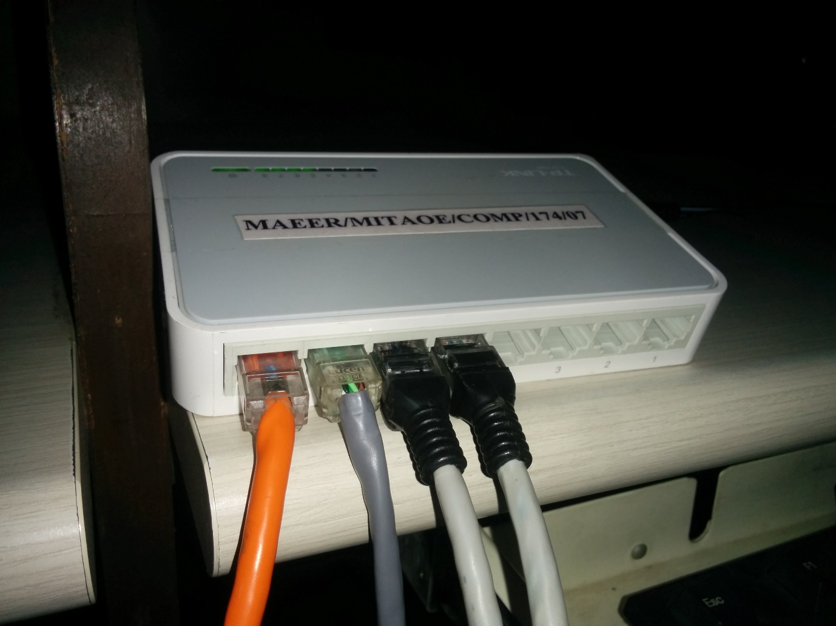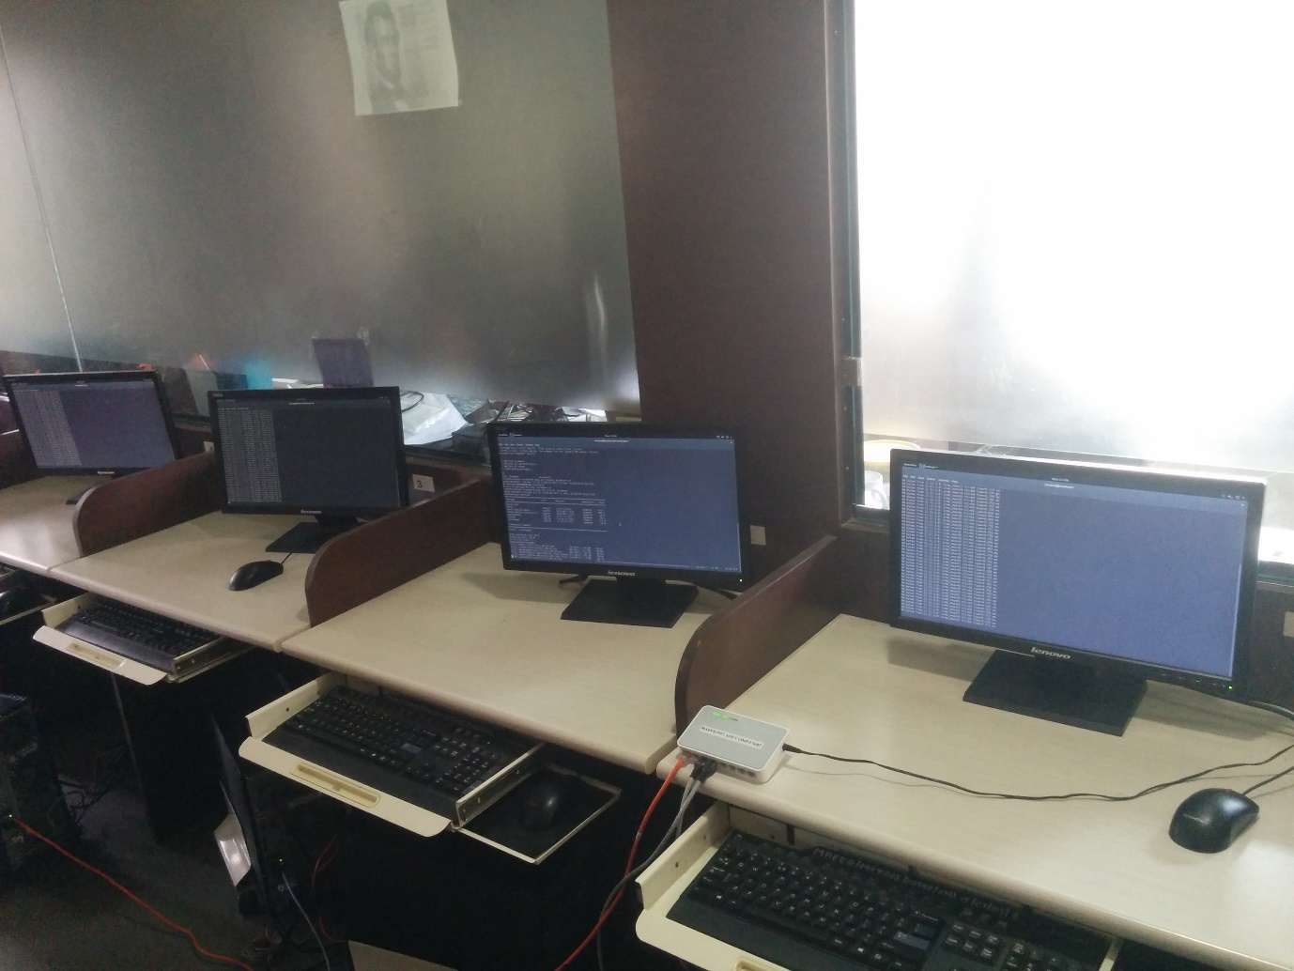d